Indoor technical
orienteering training
1
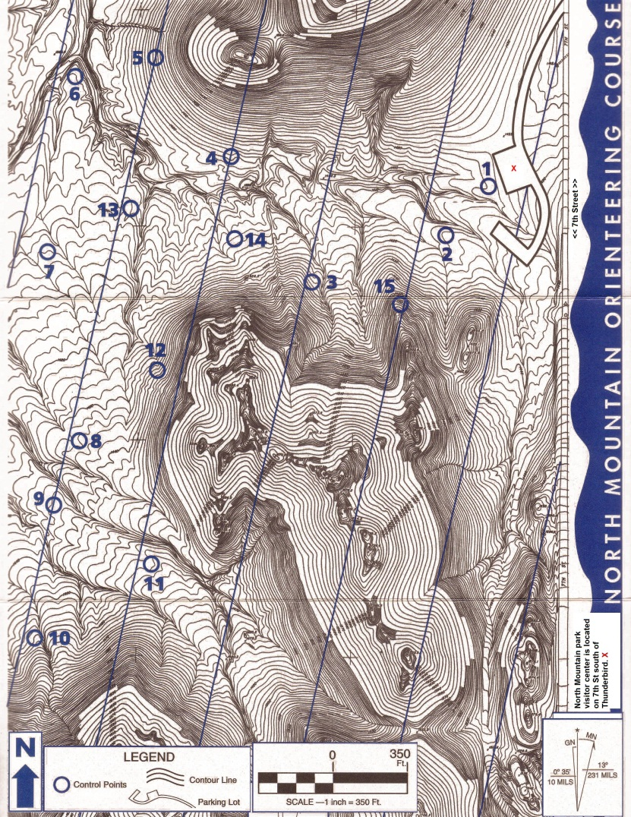

Edited by
Christian Peter MacLassen
Exercise 1:
Find 13 missing items on the map in the bottom.
Exercise 2:
Draw lines to match the pictures with the right map...

Exercise 3:
Draw lines to match the map samples with the description and with the picture below...
Exercise 4:
Draw a map of the landscape shown below.
(You are looking in the direction north.)

Exercise 5:
Draw the landscape of the map shown below.
(You are standing in the triangle looking in the direction of the black arrow)

Exercise 6:
Draw lines to match the profile picture with the map samples.

Exercise 7:
Cross out the wrong description.
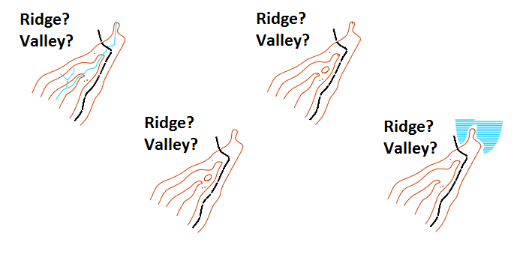
Exercise 8:
Draw the profile of the hills on the map samples below.
(The broken line indicates the profile which you will draw)

Exercise 9:
Write the correct number of the control from the map samples next to the pictures matching.
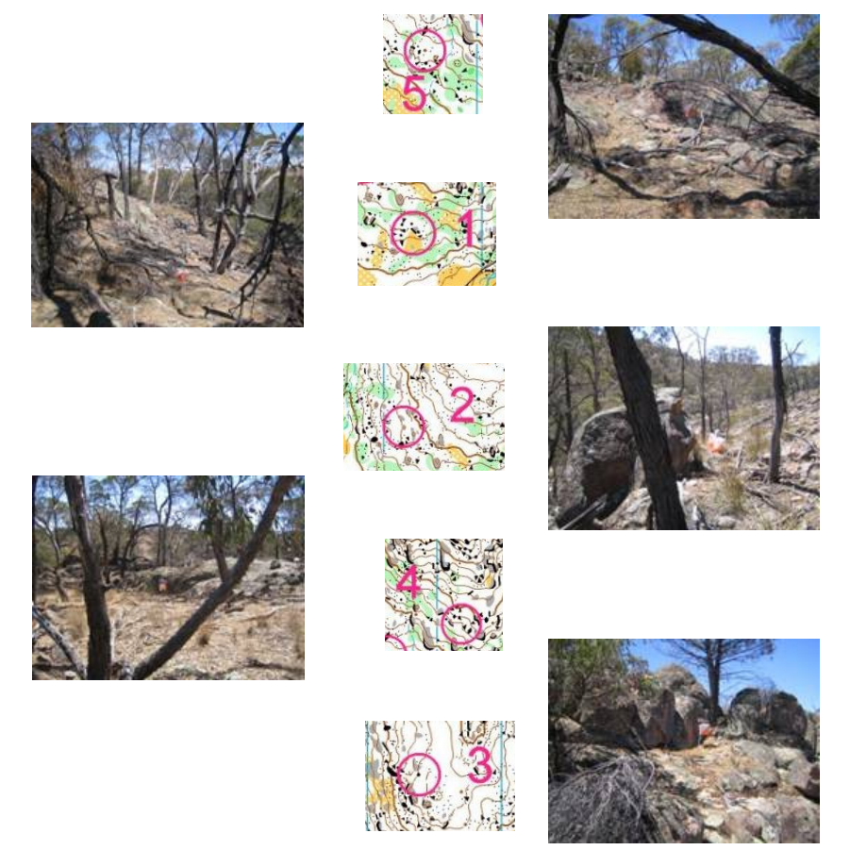

Exercise 10:
Draw lines to match the pictures with the drawn trails.

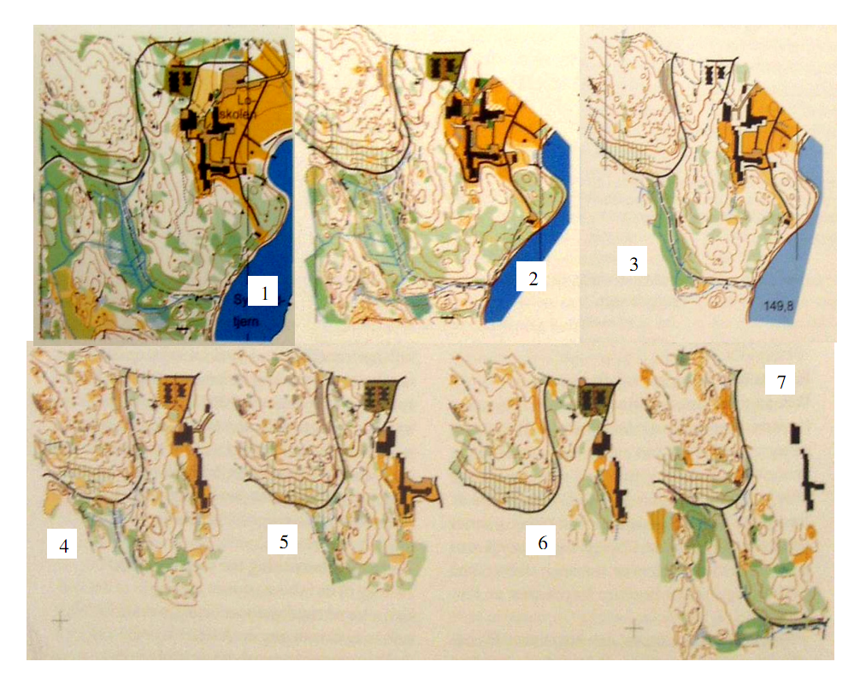
Here are six different map drawers personal idea of how to draw a map of the exact same area:

